The 13th Asian International Conference on Fluid Machinery
7th - 10th September 2015, Tokyo, Japan

AICFM13-***

Prepare the Manuscript Using this Template The Title of the Paper Should be Concise and Definitive
John Smith¹, Author 2¹ and Author 3²
¹Department of Mechanical Engineering, Xxxx University
Address, City, Postal Code, Country, author1@email.net, author2@email.net
²Department of Mechanical Engineering, Xxxx University
Address, City, Postal Code, Country, author3@email.net
Abstract
The aims, scope and conclusions of the paper must be in a self-contained abstract of a single paragraph with 60-120 words. The abstract must be informative and not just indicative and contain a summary of the significant results reported in the paper. No references should be cited. Avoid mathematical expressions as far as possible. Just below the abstract, up to six keywords should be provided.
Keywords: Just below the abstract, up to six keywords should be provided.
- Introduction
This Guide has been prepared for authors of papers submitted to AICFM13 (The 13th Asian International Conference on Fluid Machinery).
- Submission of Manuscripts
The prospective authors are invited to submit abstract of original unpublished works.
The papers already published or submitted to IJFMS (The International Journal of Fluid Machinery and Systems) are also welcomed for the oral-presentation at AIFCM13 if the authors wish to do so. Please contact the paper handling committee of AICFM13 (fmnabe@mech.kyushu-u.ac.jp) for more details.

The submission of manuscript must be done through the official web site of AICFM13, that is
http://www.aicfm13.com
The manuscript should be prepared in English and be submitted in a pdf file. Be sure to embed in the file all the fonts used in the manuscript and to make the manuscript readable with Adobe Acrobat Reader 5.0.

- Copyright Policy
The copyright belongs to the authors. The authors can submit their works to any archival journals after the conference.

- Recommendation for IJFMS Publication
AICFM13 special issue(s) are scheduled in IJFMS and the authors are encouraged to submit their papers to IJFMS. Papers of journal quality recommended by the reviewers can be published in the special issues without additional review on the content. For the information on IJFMS, please visit http://www.ijfms.org/index.html.
- Manuscript Preparation
The manuscript should be prepared using the present template. Detailed instructions on manuscript preparation are provided below. The organizing committee of AICFM13 reserves the right to return manuscripts, prior to the review, that do not conform to these instructions nor do not fit the scope of the conference.
5.1 General
Summarize the content in 6-10 pages in the present single column format. Colored figures can be included but it is recommended to make the size of the pdf file smaller than 3MB.
5.2 Layout
Place figures and tables where they are referred to for the first time in the main text. It is recommended to see a recent issue of the IJFMS to become familiar with the layout and conventions. Use 1.5 spacing and 10 or 12 pt font size and standard fonts. Number all pages consecutively.
5.3 Elements of a Paper
The basic elements of a paper are title, author names and affiliations, abstract and keywords, body of paper, acknowledgments, nomenclature, appendices, references, which should be presented in this order.
- Body of Paper
6.1 Originality
If the material has been published elsewhere except IJFMS and the paper does not include new understanding of the material or new idea, it cannot be accepted.
6.2 Reliability
The paper should not include any apparent errors in the main body of theory, equations, experiments and understanding of the results.
6.3 Expression and Structure
The expressions and the structure should be clear and concise. The paper should present proper logics and discussions on the results obtained.
6.4 Mathematics
Particular care should be exercised in identifying all symbols and in avoiding ambiguities. Equation numbers should appear in parenthesis and be numbered consecutively. All equation numbers must appear on the right-hand side of the equation. Equations should be referenced within the text as “eq. (1).” When the reference to an equation begins a sentence, the abbreviation “eq.” should be spelled out, e.g., “Equation (1).”

(1)

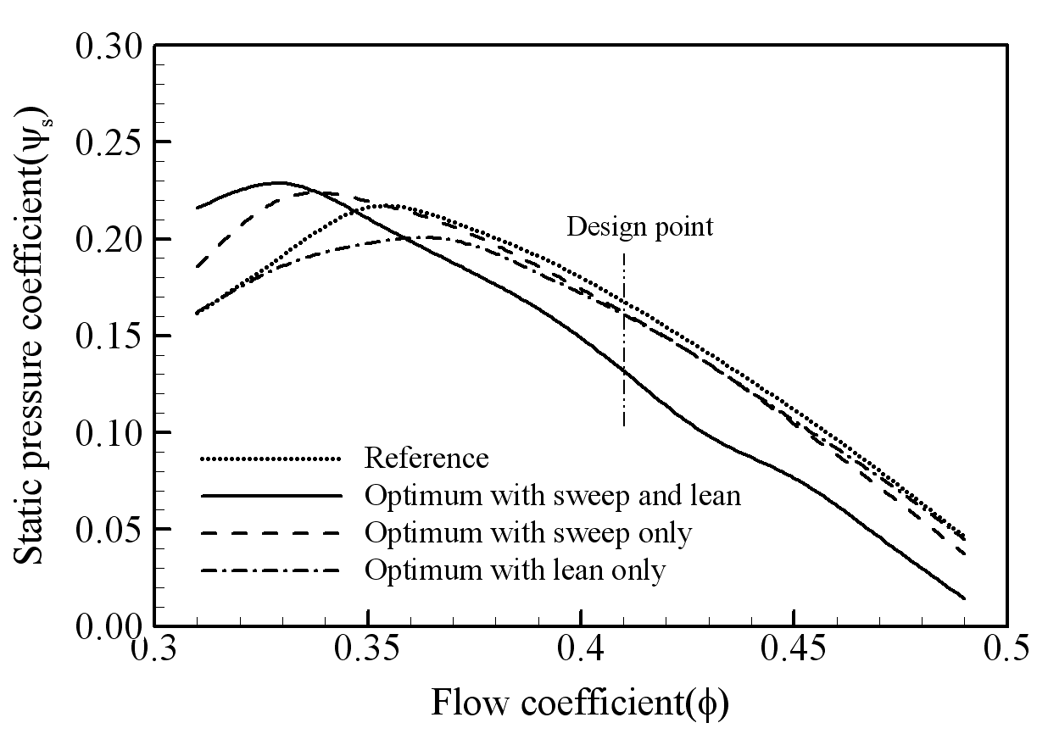

Fig. 1 Comparison of performance curves between optimum and reference blade shapes
6.5 Figures
Table 2 Reference and optimal shape
Shapes | Variables |  |  | Objectives |  | Objective function
 | H/d | H_{d}/d | d/S | Nu_{a}/Nu₀ | F_{f} | F_{surrogate} | F_{RANS} | F_{experimental}
Reference (RANS) | 1.155 | 0.289 | 0.499 | 2.279 | 1.710 | - | 0.5927 | -
Optimal (by PBA) | 0.219 | 0.264 | 0.318 | 5.065 | 2.224 | 0.3909 | 0.3975 | -

The figures should be clear and large enough so that all letters in the figures are readable. All figures should be placed where they are referred to for the first time and be numbered consecutively and have a proper caption. This number should be used when referring to the figure in text. Figure references should be included within the text in numerical order according to their order of appearance. Figures should be referenced within the text as “Fig. 1.” When the reference to a figure begins a sentence, the abbreviation “Fig.” should be spelled out, e.g., “Figure 1.”
6.6 Tables
All tables should be placed where they appear in the text for the first time and should be numbered consecutively and have a proper caption. This number should be used when referring to the table in the text. Table references should be included within the text in numerical order according to their order of appearance.
- Conclusion
The nomenclature list should be in alphabetical order with Greek symbols, also in alphabetical order and with a separate heading, following the alphabetical listing. Subscripts and superscripts should follow Greek symbols and should be identified with separate headings.
All publications cited in the text should be presented in a list of references following the text of the manuscript. In the text, make references using a number in square brackets on the line (e.g. Kim and Park [1]) and the full reference should be given in a numerical list at the end of the text. References should be styled and punctuated according to the following examples: journal article [1], book [2], thesis [3], report [4]; proceedings [5], and patent [6].
Acknowledgments
Acknowledgments may be made to individuals or institutions who have made an important contribution
Nomenclature
A_{c}  L_{x}  R_{th}  Re | Cross-section area of micro-channel [m²]  Length of heat sink [m]  Thermal resistance [ ºC/W]  Reynolds number (=U_{b}D_{h}/ν) | T  U_{i}  θ, φ  ρ | Local mean temperature [K]  Mean velocity components (i=1, 2, 3)  Design variables, W_{c}/H_{c} and W_{w}/H_{c}  Fluid Density
References
[1] Stazizar, A. J., 1985, “Investigation of Flow Phenomena in a transonic Fan Rotor Using Laser Anemometry,” ASME Journal of Engineering for Gas Turbines and Power, Vol. 107, No. 2, pp. 427-435.
[2] Myers, R. H. and Montgomery, D. C., 1995, Response Surface Methodology: Process and product optimization using designed experiments, John Wiley & Sons, New York.
[3] Guinta, A. A., 1997, “Aircraft Multidisciplinary Design Optimization Using Design of Experimental Theory and Response Surface Modeling Methods,” Ph. D. Thesis, Department of Aerospace Engineering, Virginia Polytechnic Institute and State University, Blacksburg, VA.
[4] Jameson, A., Schmidt, W., and Turkel, E., 1981, “Numerical Solutions of the Euler Equation by Finite Volume Methods Using Runge-Kutta Time Stepping Schemes,” AIAA 81-1259.
[5] Denton, J. D., Xu, L., 2002, “The Effects of Lean and Sweep on Transonic Fan Performance,” ASME Turbo Expo, Amsterdam, Netherlands, GT-2002-30327.
[6] T. Burns, 1995, US Patent No. 358498.

